|  |  |
| --- | --- |
| **Course and Module Information** | |
| **Academic Year** | 2018 - 2019 |
| **Semester** | 2 |
| **Course** | BSCH |
| **Year** | 1 |
| **Module** | Software Development 1 |
|  |  |
| **MILESTONE** | **REVIEW** |

|  |
| --- |
| **Instructions** |
| 1. **Fill in your details in the box provided below.** 2. **Answer the questions including screenshots where appropriate.** |

|  |  |
| --- | --- |
| **Student Information** | |
| **Student Name** | Oguz Sarac |
| **Student Number** | 2988989 |
| **Code Review #** | 3 |

|  |
| --- |
| **Plan**  ***(20%)*** |
| Please state the design objectives for your Robocode project  Basic Behaviour: Robot should move randomly to assist in avoiding enemy fire. Robot should shoot while on the move, so it doesn't expose itself by sitting still to shoot.    When seeing another robot: Shoot continuously while moving.    When taking damage: Nothing - continue moving randomly, no point doing anything else.    When hitting obstruction: Reverse direction. |

|  |
| --- |
| **Modifications**  ***(20%)*** |
| Please list the changes that have been made to your Robocode since your last code review in bullet-point format (one sentence each), including a screenshot of the output from the command: *git log --reverse*   * Version 4.0 of Beast robot uploaded * Distance control simplified to improve performance * Rotation string fixed to aid movement mechanics * Fully replaced code for weapon mechanics * Stop-and-Go death limit changed from 3 to 2 |
|  |

**Oguz:**

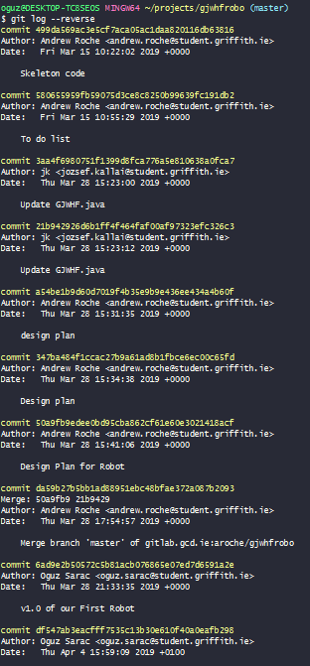

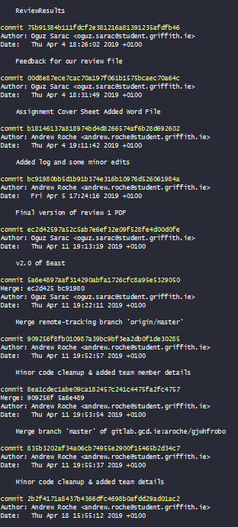

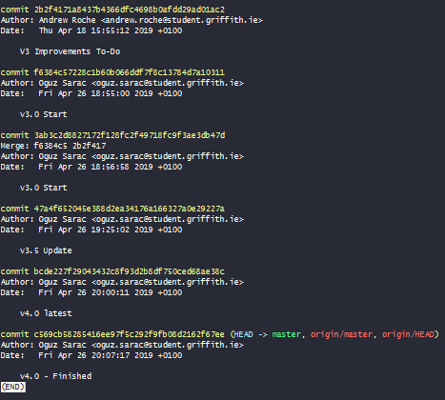

|  |
| --- |
| **Updates**  ***(20%)*** |
| Please list the updates and bug fixes you intend to make for the next code review   * Robot engages first target that it has line of sight with. While this allows it to excel in scenarios where there are either so few targets that targeting is irrelevant, or so many that it is impossible not to hit an opponent, this can cause issues with combat performance. To solve this, code can be added to the radar so that any detected opponent returns its distance to Beast, with the gun being directed at the closest target determined by the last 360 degree scan. |

|  |
| --- |
| **Sharing**  ***(10%)*** |
| Please list the students who have contributed to your Robocode (this will be compared to your ‘contributors’ list on Griffith GitLab)   * Oguz Sarac |

|  |
| --- |
| **Repository**  ***(10%)*** |
| Lecturer confirms access to your Griffith GitLab repository (Y/N) |

|  |
| --- |
| **Code**  ***(10%)*** |
| Lecturer confirms source code has been reviewed on your computer (Y/N) |

|  |
| --- |
| **Robot**  ***(10%)*** |
| Lecture confirms download of your robot for testing from Griffith GitLab (Y/N) |

**Bug Name:** Robot targeting

**Bug ID:** 1

**Build Number:** 4.0

**Severity:** Medium

**Priority:** Medium

**Assigned to:** Team

**Reported By:** Andrew Roche

**Reported On:** 26/04/19

**Reason:** Robot attacks the first target the scanner detects, regardless of distance

**Status:** Active

**Environment:** Robocode

**Description:**

The robot fires at the most recent target that the scanner detects since last firing. This can cause it to target opponents too far away to reliably hit, decreasing combat performance.

**Steps To Reproduce:**

Issue is immediately apparent ins any battle where there are multiple possible opponents to target.

**Expected result:** Robot should target only opponents that it can reliably hit.

**Proposed action/s to eliminate bug:** Code can be added to the radar’s functions so that it returns the distance of all opponents detected in a 360 degree sweep, with the shortest distance being designated as the target.